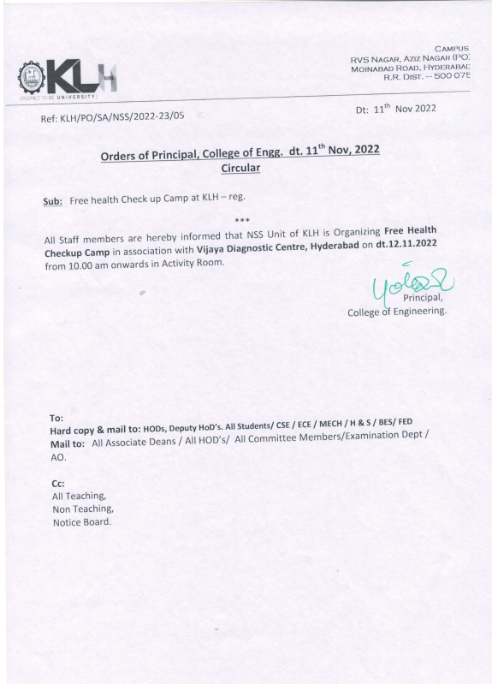



**STAFF HEALTH CAMP 2022**

**Date of Event: 12-11-2022**

**Time: 10:00 -11:30 pm**

**Location of Event: Activity Room**

**Number of Persons Attending: 86**

**Faculty Coordinator:** **Dr. Mardanpally Mallesh**

**Conducted By: National Service Scheme**

Today 12 November 2022 Staff Health Checkup camp was held for all faculty members. A thorough checkup was done for all faculty members and analyzed if they had any problems and suggested acc to it.

All of them participated in this. This shows the active participation of the KLH team. This helped the faculty to know how healthy they are.

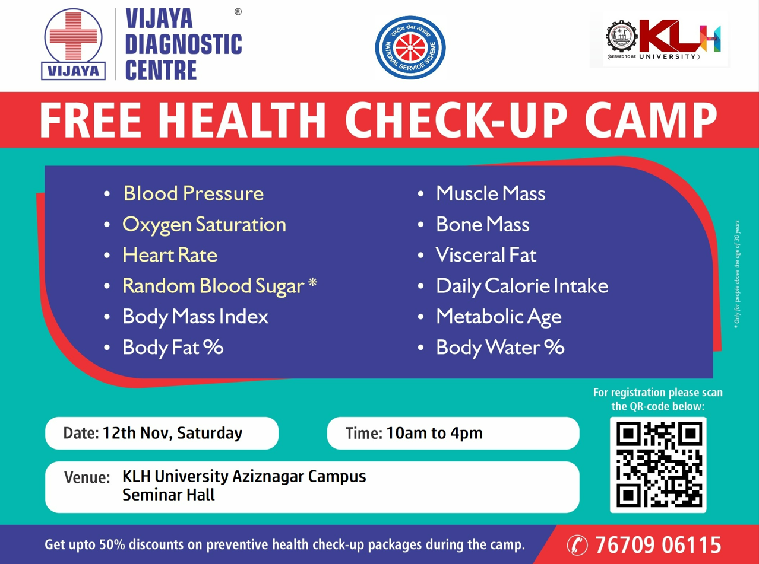

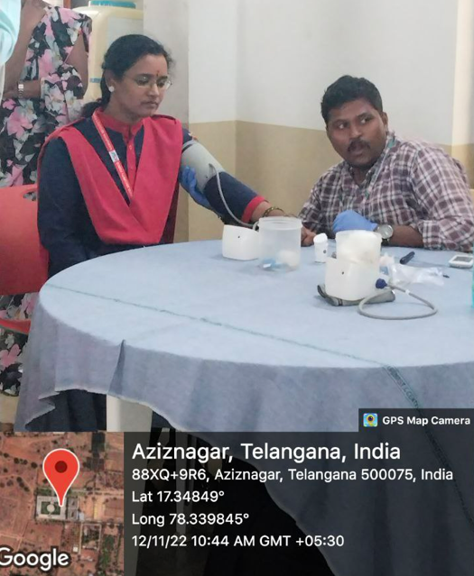

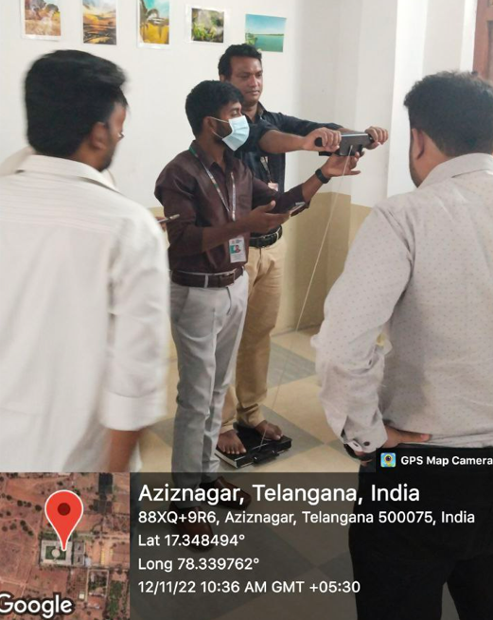 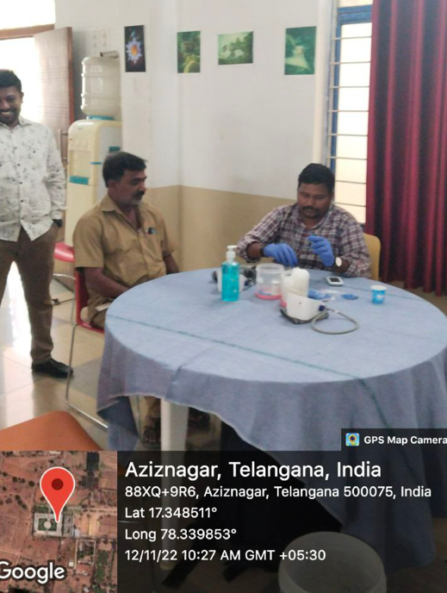

**STAFF PARTICIPATION LIST:**

|  |  |  |  |  |  |  |  |  |  |  |  |  |  |  |  |  |  |  |  |  |  |  |  |  |  |  |
| --- | --- | --- | --- | --- | --- | --- | --- | --- | --- | --- | --- | --- | --- | --- | --- | --- | --- | --- | --- | --- | --- | --- | --- | --- | --- | --- |
| **S NO** | **CampName** | **CampDate** | **CUST_ID** | **CUST_NAME** | **AGE** | **GENDER** | **PHONE** | **EMAIL** | **HEIGHT** | **WEIGHT** | **BODY FAT** | **MUSCLE MASS** | **BONE MASS** | **BMI** | **DCI BMR** | **METABOLIC AGE** | **BODY WATER** | **VISCERAL FAT** | **BP** | **HEART RATE** | **RBS** | **Z_SCORE** | **T_SCORE** | **BQI** | **Is_Bought** | **Lead** |
| 1 | KLH University Aziznagar | 2022-11-12 | 2211010069 | Sandeep Samaleti | 32 | M | 7569068386 | sandeep.samaleti@gmail.com | 5.7 | 64.2 | 21.6 | 47.7 | 2.6 | 22.2 | 2109 | 34 | 50.6 | 8 | 110/74 | 68 | 97 |  |  |  | No | Cold |
| 2 | KLH University Aziznagar | 2022-11-12 | 2211010096 | Vijay Kumar Damera | 39 | M | 9959559905 | vijay.kumar@klh.edu.in | 163 | 77.9 | 30.6 | 51.2 | 2.8 | 29.3 | 2281 | 64 | 45.1 | 14 | 121/87 | 66 | 80 |  |  |  | No | Warm |
| 3 | KLH University Aziznagar | 2022-11-12 | 2211010100 | K Venkata Ramana Reddy | 53 | M | 8106850990 | kvramana.reddy2019@gmail.com | 169 | 67.1 | 21.4 | 50 | 2.7 | 23.5 | 2158 | 39 | 54.3 | 12 | 124/81 | 78 | 112 |  |  |  |  | null |
| 4 | KLH University Aziznagar | 2022-11-12 | 2211010108 | M Banerjee | 38 | M | 7587099426 | moonbanerjee@klh.edu.in | 184 | 81.4 | 21.6 | 60.5 | 3.3 | 24 | 2704 | 31 | 52.7 | 11 | 117/81 | 83 | 112 |  |  |  | No | Cold |
| 5 | KLH University Aziznagar | 2022-11-12 | 2211010127 | Meenakshi Chaubey | 27 | F | 7895359716 | meenakshichaubey71@gmail.com | 157 | 67 | 40.8 | 37.4 | 2.3 | 27.2 | 1892 | 52 | 41 | 7 | 115/84 | 93 | 0 |  |  |  | No | Cold |
| 6 | KLH University Aziznagar | 2022-11-12 | 2211010149 | Dr Japa Aditya | 31 | M | 8319291344 | aditya.japa@klh.edu.in | 170 | 53.9 | 18.9 | 41.4 | 2.3 | 18.6 | 1827 | 27 | 51.1 | 5 | 119/69 | 56 | 85 |  |  |  |  | null |
| 7 | KLH University Aziznagar | 2022-11-12 | 2211010165 | Panduraju Pagidimalla | 32 | M | 8985847780 | p.panduraju@gmail.com | 166 | 79.9 | 28.4 | 54.2 | 3 | 29 | 2443 | 52 | 47.3 | 13 | 145/99 | 94 | 0 |  |  |  | No | Cold |
| 8 | KLH University Aziznagar | 2022-11-12 | 2211010170 | Dr Joshitha C | 35 | F | 9074545969 | joshitha@klh.edu.in | 154 | 70.6 | 43.5 | 37.6 | 2.3 | 29.8 | 1887 | 60 | 41.2 | 9 | 123/90 | 82 | 103 | 0 | -1 | 84.7 | No | Cold |
| 9 | KLH University Aziznagar | 2022-11-12 | 2211010244 | K Jagan Mohan Rao | 39 | M | 9989237734 | kjmrao@klh.edu.in | 170 | 68.3 | 23 | 49.8 | 2.7 | 23.6 | 2188 | 39 | 50.8 | 10 | 115/84 | 75 | 83 | 0 | -1.5 | 79.5 | No | Cold |
| 10 | KLH University Aziznagar | 2022-11-12 | 2211020007 | Dr M P Mallesh | 48 | M | 9291518420 | mardanpallypeddam@gmail.com | 158 | 65.6 | 28.7 | 44.4 | 2.5 | 26.3 | 1933 | 62 | 46.5 | 14 | 136/95 | 80 | 115 |  |  |  | No | Warm |
| 11 | KLH University Aziznagar | 2022-11-12 | 2211090017 | Dr. B. Chandrashekar | 40 | M | 9676547506 | chandumadhu.ram@gmail.com | 155 | 72.9 | 32 | 47 | 2.6 | 30.3 | 2085 | 65 | 44.2 | 15 | 165/107 | 79 | 114 | 0 | -1.3 | 83.2 | No | Cold |
| 12 | KLH University Aziznagar | 2022-11-12 | 2211110040 | Kalyan Kumar P | 44 | M | 9063010201 | kalyan.palaparthi77@gmail.com | 5.9 | 81.1 | 27.4 | 55.9 | 3.1 | 26.5 | 2478 | 52 | 47.7 | 14 | 135/94 | 77 | 130 |  |  |  | No | Cold |
| 13 | KLH University Aziznagar | 2022-11-12 | 2211110046 | B. VENKATESHWAR RAO | 49 | M | 9963043462 | bollagani.venkateswarrao@gmail.com | 6 | 85.4 | 23.2 | 62.2 | 3.4 | 25.8 | 2766 | 37 | 53.5 | 14 | 187/115 | 67 | 124 | 0 | -1.3 | 82.7 | No | Cold |
| 14 | KLH University Aziznagar | 2022-11-12 | 2211110047 | K Vijayender Reddy | 56 | M | 9550463869 | kanugantivijayenderreddy@gmail.com | 160 | 82.6 | 34.5 | 51.3 | 2.8 | 32.3 | 2265 | 81 | 43.9 | 19 | 150/84 | 69 | 122 | 0 | -1.4 | 80 | Yes | Hot |
| 15 | KLH University Aziznagar | 2022-11-12 | 2211110049 | Krushnachandra Panigrahy | 30 | M | 9439151718 | kpanigrahy@klh.edu.in | 169 | 56.7 | 19.9 | 43 | 2.4 | 19.8 | 1906 | 29 | 50.7 | 6 | 114/86 | 83 | 0 | 0 | -1.6 | 77.8 |  | null |
| 16 | KLH University Aziznagar | 2022-11-12 | 2211110064 | Varkolu Mohan | 36 | M | 9491873240 | mohan.iict@gmail.com | 170 | 76.4 | 26.3 | 53.4 | 2.9 | 26.4 | 2377 | 47 | 48.4 | 12 | 134/85 | 72 | 102 |  |  |  |  | null |
| 17 | KLH University Aziznagar | 2022-11-12 | 2211110066 | l LINGARAJU PHANIKUMAR | 35 | M | 9490217015 | phani@klh.edu.in | 153 | 81.7 | 34.3 | 50.8 | 2.8 | 34.9 | 2292 | 60 | 44 | 17 | 131/89 | 83 | 102 |  |  |  | No | Cold |
| 18 | KLH University Aziznagar | 2022-11-12 | 2211110067 | Subhranginee Das | 37 | F | 9438492717 | subhranginee@gmail.com | 158 | 60.6 | 36 | 36.5 | 2.2 | 24.3 | 1764 | 49 | 44.8 | 6 | 100/68 | 76 | 103 | 0 | -0.2 | 100 |  | null |
| 19 | KLH University Aziznagar | 2022-11-12 | 2211110090 | Tanushree Sarkar | 34 | F | 8639193063 | tsarkar81@gmail.com | 160 | 67 | 39.9 | 37.9 | 2.4 | 26.2 | 1875 | 57 | 41.2 | 7 | 123/93 | 98 | 87 | 0 | -1.5 | 76.6 | Yes | Hot |
| 20 | KLH University Aziznagar | 2022-11-12 | 2211110101 | Dr. Datrika Srinivas Rao | 40 | M | 9949933889 | dsrao@klh.edu.in | 168 | 80.4 | 24 | 57.9 | 3.2 | 28.5 | 2576 | 39 | 54.5 | 14 | 146/98 | 75 | 106 | 0 | -1.5 | 78.2 | No | Cold |
| 21 | KLH University Aziznagar | 2022-11-12 | 2211110103 | Sunil Kamal | 31 | M | 9459832825 | snlkml1990@gmail.com | 173 | 74.8 | 23.2 | 54.2 | 3 | 25 | 2440 | 35 | 50.9 | 10 | 129/73 | 71 | 138 |  |  |  |  | null |
| 22 | KLH University Aziznagar | 2022-11-12 | 2211110104 | Dr Pramoda Patro | 37 | M | 7972864533 | pramoda.mtech09@gmail.com | 5.4 | 88.7 | 36.5 | 53.4 | 2.9 | 33.4 | 2420 | 62 | 38.7 | 17 | 146/86 | 82 | 103 |  |  |  | No | Cold |
| 23 | KLH University Aziznagar | 2022-11-12 | 2211120001 | P.RRAVEEN KUMAR | 37 | M | 9908715150 | praveen@klh.edu.in | 5.7 | 83.4 | 29.2 | 56 | 3.1 | 28.9 | 2512 | 56 | 46.5 | 14 | 125/86 | 80 | 129 |  |  |  |  | null |
| 24 | KLH University Aziznagar | 2022-11-12 | 2211120019 | BHANDARY SUNEEL KUMAR | 51 | M | 9133257151 | bsk01anirudh@gmail.com | 160 | 45.2 | 12.4 | 37.6 | 2.1 | 17.7 | 1589 | 26 | 60.2 | 2 | 111/71 | 82 | 121 |  |  |  |  | null |
| 25 | KLH University Aziznagar | 2022-11-12 | 2211120022 | Md.Iqbal | 53 | M | 8688090572 |  | 164 | 70.5 | 27.8 | 48.2 | 2.7 | 26.2 | 2096 | 59 | 48.1 | 14 | 148/86 | 79 | 158 |  |  |  |  | null |
| 26 | KLH University Aziznagar | 2022-11-12 | 2211120024 | S sathyam | 35 | M | 9948895841 | praveen@klh.edu.in | 5.6 | 84.1 | 26.9 | 58.3 | 3.2 | 30.1 | 2623 | 46 | 51.3 | 14 | 124/80 | 92 | 166 |  |  |  | No | Cold |
| 27 | KLH University Aziznagar | 2022-11-12 | 2211120037 | M.P. Actlin Jeeva | 33 | F | 8903533133 | actlinjeevamp@klh.edu.in | 160 | 73.9 | 42.2 | 40.1 | 2.6 | 28.9 | 2016 | 58 | 41.4 | 8 | 117/80 | 73 | 88 |  |  |  | No | Cold |
| 28 | KLH University Aziznagar | 2022-11-12 | 2211120038 | Sujini | 43 | F | 8688098891 | sujini.a@klh.edu.in | 160 | 67.2 | 40 | 37.9 | 2.4 | 26.2 | 1849 | 61 | 41.8 | 8 | 142/78 | 69 | 93 |  |  |  | No | Cold |
| 29 | KLH University Aziznagar | 2022-11-12 | 2211120049 | Murali dharan | 61 | M | 9849011612 |  | 170 | 62.5 | 24.9 | 44.5 | 2.5 | 21.6 | 1907 | 52 | 48.9 | 13 | 126/80 | 78 | 135 |  |  |  | No | Cold |
| 30 | KLH University Aziznagar | 2022-11-12 | 2211120050 | MD.Jani | 55 | M | 6305530773 | praveen@klh.edu.in | 5.7 | 68.9 | 19.2 | 52.8 | 2.9 | 23.8 | 2279 | 32 | 57.8 | 12 | 126/75 | 75 | 447 |  |  |  |  | null |
| 31 | KLH University Aziznagar | 2022-11-12 | 2211120058 | Talari Vivek | 31 | M | 9160321493 |  | 180 | 80 | 24 | 57.7 | 3.1 | 24.7 | 2598 | 36 | 49.3 | 10 | 123/77 | 72 | 87 |  |  |  |  | null |
| 32 | KLH University Aziznagar | 2022-11-12 | 2211120059 | Dr. Sreedhar G | 39 | M | 9909651832 | sreedhar.gundekari@gmail.com | 167 | 73.1 | 27.3 | 50.3 | 2.8 | 26.2 | 2226 | 53 | 47.1 | 12 | 153/95 | 94 | 94 |  |  |  | No | Cold |
| 33 | KLH University Aziznagar | 2022-11-12 | 2211120062 | Jeevani | 31 | F | 9177644408 |  | 165 | 93.4 | 48.2 | 45.3 | 3.1 | 34.3 | 2386 | 56 | 39.1 | 11 | 135/79 | 87 | 109 | 0 | -1.2 | 81.6 | No | Warm |
| 34 | KLH University Aziznagar | 2022-11-12 | 2211120067 | Giridhar | 38 | M | 7898104488 | giridharurkude@gmail.com | 175 | 84.3 | 29.8 | 56.2 | 3.1 | 27.5 | 2520 | 58 | 44.5 | 14 | 126/85 | 78 | 162 |  |  |  |  | null |
| 35 | KLH University Aziznagar | 2022-11-12 | 2211120068 | Dr. Ghanahshyam | 30 | M | 8807749585 | ghana8492@gmail.com | 171 | 72.4 | 25 | 51.4 | 2.8 | 24.7 | 2306 | 41 | 48 | 10 | 146/95 | 86 | 0 |  |  |  |  | null |
| 36 | KLH University Aziznagar | 2022-11-12 | 2211120070 | G Madhukar rao | 36 | M | 9177260474 | madhusw511@gmail.com | 181 | 85.2 | 22.3 | 62.8 | 3.4 | 26 | 2829 | 32 | 53.6 | 12 | 130/82 | 66 | 99 | 0 | -0.9 | 90.1 | No | Cold |
| 37 | KLH University Aziznagar | 2022-11-12 | 2211120071 | Pankaj kumar | 44 | M | 6302989536 |  | 5.7 | 83.6 | 29 | 56.3 | 3.1 | 28.9 | 2507 | 57 | 47.8 | 15 | 120/81 | 92 | 121 |  |  |  |  | null |
| 38 | KLH University Aziznagar | 2022-11-12 | 2211120075 | Ramesh Ade | 38 | M | 9000955238 | ramesh.ade1983@gmail.com | 166 | 69.9 | 28.2 | 47.6 | 2.6 | 25.4 | 2103 | 56 | 45 | 11 | 169/98 | 155 | 103 |  |  |  | No | Cold |
| 39 | KLH University Aziznagar | 2022-11-12 | 2211120078 | Aakella prasanna lakshmi | 33 | F | 7995461288 | prasannalakshmi.akella@klh.edu.in | 154 | 75.3 | 45.5 | 38.7 | 2.4 | 31.8 | 1973 | 58 | 40.9 | 10 | 105/71 | 81 | 77 |  |  |  | No | Cold |
| 40 | KLH University Aziznagar | 2022-11-12 | 2211120080 | Dr.K.SRINIVAS | 52 | M | 9963418837 | srirecw9@gmail.com | 168 | 86.6 | 32.4 | 55.5 | 3 | 30.7 | 2465 | 73 | 45.1 | 17 | 141/83 | 88 | 92 | 0 | -1.2 | 84.1 | Yes | Hot |
| 41 | KLH University Aziznagar | 2022-11-12 | 2211120096 | Ch.yedukondalu | 33 | M | 9701407967 | chyedukondalu12@gmail.com | 166 | 79.4 | 29.2 | 53.3 | 2.9 | 28.8 | 2395 | 55 | 46 | 13 | 120/80 | 80 | 125 | 0 | -1.4 | 81.6 | No | Cold |
| 42 | KLH University Aziznagar | 2022-11-12 | 2211120097 | KOLLI LALITHA KUMARI | 31 | F | 6301446267 | lalithak1208@gmail.com | 166 | 53 | 30.3 | 34.9 | 2.1 | 19.2 | 1670 | 33 | 45.3 | 3 | 108/71 | 80 | 107 |  |  |  | No | Cold |
| 43 | KLH University Aziznagar | 2022-11-12 | 2211120103 | Dr. VIJAY Rao Kumbhare | 36 | M | 7000941127 | vijay.rao@klh.edu.in | 163 | 61.9 | 20.5 | 46.7 | 2.6 | 23.3 | 2045 | 33 | 53.7 | 9 | 149/49 | 62 | 93 |  |  |  | No | Cold |
| 44 | KLH University Aziznagar | 2022-11-12 | 2211120113 | Ravi Boda | 40 | M | 9441681307 | raviou2015@gmail.com | 173 | 81.7 | 24.8 | 58.3 | 3.2 | 27.3 | 2598 | 41 | 52 | 13 | 147/85 | 73 | 0 |  |  |  |  | null |
| 45 | KLH University Aziznagar | 2022-11-12 | 2211120118 | Sandeep | 32 | M | 8688525624 |  | 173 | 79.9 | 31.7 | 51.8 | 2.8 | 26.7 | 2339 | 57 | 40.3 | 12 | 136/76 | 94 | 0 |  |  |  | No | Cold |
| 46 | KLH University Aziznagar | 2022-11-12 | 2211120124 | Dr B Lalitha | 53 | F | 9490017562 |  | 162 | 88.2 | 48.9 | 42.3 | 2.8 | 33.6 | 2163 | 78 | 37.7 | 12 | 136/80 | 86 | 182 | 0 | -0.7 | 83 | No | Cold |
| 47 | KLH University Aziznagar | 2022-11-12 | 2211120127 | Balaji s | 53 | M | 9502899290 |  | 180 | 103.6 | 35.2 | 63.4 | 3.4 | 32 | 2880 | 78 | 41.2 | 19 | 122/81 | 106 | 129 | 0 | -2 | 69.3 | No | Cold |
| 48 | KLH University Aziznagar | 2022-11-12 | 2211120135 | Sukla Satapathy | 37 | F | 8763216405 | sukla.iit@gmail.com | 157 | 60.9 | 36.1 | 36.6 | 2.2 | 24.7 | 1769 | 49 | 45.2 | 6 | 116/78 | 105 | 146 |  |  |  | No | Cold |
| 49 | KLH University Aziznagar | 2022-11-12 | 2211120139 | Manisha | 31 | F | 7004317424 | mani.k2321@gmail.com | 152 | 55.5 | 35.7 | 33.7 | 2 | 24 | 1648 | 45 | 45.1 | 5 | 133/92 | 100 | 104 |  |  |  | No | Cold |
| 50 | KLH University Aziznagar | 2022-11-12 | 2211120064 | Ambika | 35 | F | 7989729704 | ambhika@gmail.com |  |  |  |  |  |  |  |  |  |  | 113/87 | 100 | 85 |  |  |  |  | null |
| 51 | KLH University Aziznagar | 2022-11-12 | 2211120021 | V veereshgoud | 32 | M | 9963649510 | veeragoniveereshgoud232@gmail.com |  |  |  |  |  |  |  |  |  |  | 129/87 | 99 | 199 |  |  |  |  | null |
| 52 | KLH University Aziznagar | 2022-11-12 | 2211120017 | T.BALRAJ | 45 | M | 9603665744 | mudirajbalarajmudiraj@gamil.com |  |  |  |  |  |  |  |  |  |  | 109/71 | 86 | 181 |  |  |  |  | null |
| 53 | KLH University Aziznagar | 2022-11-12 | 2211010098 | CH SANDEEP REDDY | 35 | M | 9959125290 | sandeep@klh.edu.in | ***Absent*** | ***Absent*** | ***Absent*** | ***Absent*** | ***Absent*** | ***Absent*** | ***Absent*** | ***Absent*** | ***Absent*** | ***Absent*** | ***Absent*** | ***Absent*** | ***Absent*** | ***Absent*** | ***Absent*** | ***Absent*** | ***Absent*** | ***Absent*** |
| 54 | KLH University Aziznagar | 2022-11-12 | 2211010103 | PRASHANTH VIJAYENDRA RAO KARANAM | 40 | M | 9441232633 | prashanth@klh.edu.in | ***Absent*** | ***Absent*** | ***Absent*** | ***Absent*** | ***Absent*** | ***Absent*** | ***Absent*** | ***Absent*** | ***Absent*** | ***Absent*** | ***Absent*** | ***Absent*** | ***Absent*** | ***Absent*** | ***Absent*** | ***Absent*** | ***Absent*** | ***Absent*** |
| 55 | KLH University Aziznagar | 2022-11-12 | 2211010113 | Geeta Singh | 42 | F | 7680854848 | geeta.singh@klh.edu.in | ***Absent*** | ***Absent*** | ***Absent*** | ***Absent*** | ***Absent*** | ***Absent*** | ***Absent*** | ***Absent*** | ***Absent*** | ***Absent*** | ***Absent*** | ***Absent*** | ***Absent*** | ***Absent*** | ***Absent*** | ***Absent*** | ***Absent*** | ***Absent*** |
| 56 | KLH University Aziznagar | 2022-11-12 | 2211010133 | Dr. Sheikh Fahad Ahmad | 35 | M | 9919491430 | er.fahad@gmail.com | ***Absent*** | ***Absent*** | ***Absent*** | ***Absent*** | ***Absent*** | ***Absent*** | ***Absent*** | ***Absent*** | ***Absent*** | ***Absent*** | ***Absent*** | ***Absent*** | ***Absent*** | ***Absent*** | ***Absent*** | ***Absent*** | ***Absent*** | ***Absent*** |
| 57 | KLH University Aziznagar | 2022-11-12 | 2211010213 | P Ratna Kumar | 49 | M | 9885419909 | rk30111972@klh.edu.in | ***Absent*** | ***Absent*** | ***Absent*** | ***Absent*** | ***Absent*** | ***Absent*** | ***Absent*** | ***Absent*** | ***Absent*** | ***Absent*** | ***Absent*** | ***Absent*** | ***Absent*** | ***Absent*** | ***Absent*** | ***Absent*** | ***Absent*** | ***Absent*** |
| 58 | KLH University Aziznagar | 2022-11-12 | 2211010246 | Sudharshan Babu Pandava | 29 | M | 9492634031 | sudharshanbabu.p@gmail.com | ***Absent*** | ***Absent*** | ***Absent*** | ***Absent*** | ***Absent*** | ***Absent*** | ***Absent*** | ***Absent*** | ***Absent*** | ***Absent*** | ***Absent*** | ***Absent*** | ***Absent*** | ***Absent*** | ***Absent*** | ***Absent*** | ***Absent*** | ***Absent*** |
| 59 | KLH University Aziznagar | 2022-11-12 | 2211020002 | M.Saidireddy | 43 | M | 9963850858 | msreddy33@gmail.com | ***Absent*** | ***Absent*** | ***Absent*** | ***Absent*** | ***Absent*** | ***Absent*** | ***Absent*** | ***Absent*** | ***Absent*** | ***Absent*** | ***Absent*** | ***Absent*** | ***Absent*** | ***Absent*** | ***Absent*** | ***Absent*** | ***Absent*** | ***Absent*** |
| 60 | KLH University Aziznagar | 2022-11-12 | 2211020003 | Dr. A K VARMA | 31 | M | 9308295008 | ashwinikumar.varma@klh.edu.in | ***Absent*** | ***Absent*** | ***Absent*** | ***Absent*** | ***Absent*** | ***Absent*** | ***Absent*** | ***Absent*** | ***Absent*** | ***Absent*** | ***Absent*** | ***Absent*** | ***Absent*** | ***Absent*** | ***Absent*** | ***Absent*** | ***Absent*** | ***Absent*** |
| 61 | KLH University Aziznagar | 2022-11-12 | 2211020010 | Dr P Suresh kumar | 47 | M | 8309090343 | librarian@klh.edu.in | ***Absent*** | ***Absent*** | ***Absent*** | ***Absent*** | ***Absent*** | ***Absent*** | ***Absent*** | ***Absent*** | ***Absent*** | ***Absent*** | ***Absent*** | ***Absent*** | ***Absent*** | ***Absent*** | ***Absent*** | ***Absent*** | ***Absent*** | ***Absent*** |
| 62 | KLH University Aziznagar | 2022-11-12 | 2211020012 | VENKAT REDDY PITTA | 44 | M | 7729090414 | venkanna.pitta@gmail.com | ***Absent*** | ***Absent*** | ***Absent*** | ***Absent*** | ***Absent*** | ***Absent*** | ***Absent*** | ***Absent*** | ***Absent*** | ***Absent*** | ***Absent*** | ***Absent*** | ***Absent*** | ***Absent*** | ***Absent*** | ***Absent*** | ***Absent*** | ***Absent*** |
| 63 | KLH University Aziznagar | 2022-11-12 | 2211050018 | Girish Chandra D | 31 | M | 9959843228 | girish.chandra@klh.edu | ***Absent*** | ***Absent*** | ***Absent*** | ***Absent*** | ***Absent*** | ***Absent*** | ***Absent*** | ***Absent*** | ***Absent*** | ***Absent*** | ***Absent*** | ***Absent*** | ***Absent*** | ***Absent*** | ***Absent*** | ***Absent*** | ***Absent*** | ***Absent*** |
| 64 | KLH University Aziznagar | 2022-11-12 | 2211050020 | D LAVANYA | 30 | F | 9515045760 |  | ***Absent*** | ***Absent*** | ***Absent*** | ***Absent*** | ***Absent*** | ***Absent*** | ***Absent*** | ***Absent*** | ***Absent*** | ***Absent*** | ***Absent*** | ***Absent*** | ***Absent*** | ***Absent*** | ***Absent*** | ***Absent*** | ***Absent*** | ***Absent*** |
| 65 | KLH University Aziznagar | 2022-11-12 | 2211050033 | T VIVEK | 31 | M | 9160321493 |  | ***Absent*** | ***Absent*** | ***Absent*** | ***Absent*** | ***Absent*** | ***Absent*** | ***Absent*** | ***Absent*** | ***Absent*** | ***Absent*** | ***Absent*** | ***Absent*** | ***Absent*** | ***Absent*** | ***Absent*** | ***Absent*** | ***Absent*** | ***Absent*** |
| 66 | KLH University Aziznagar | 2022-11-12 | 2211090020 | RAMESH ADE | 38 | M | 900955238 | ramesh.ade1983@gmail.com | ***Absent*** | ***Absent*** | ***Absent*** | ***Absent*** | ***Absent*** | ***Absent*** | ***Absent*** | ***Absent*** | ***Absent*** | ***Absent*** | ***Absent*** | ***Absent*** | ***Absent*** | ***Absent*** | ***Absent*** | ***Absent*** | ***Absent*** | ***Absent*** |
| 67 | KLH University Aziznagar | 2022-11-12 | 2211110044 | Dr.Bhavani Sushma | 38 | F | 9488892399 | bhavanisushma2007@gmail.com | ***Absent*** | ***Absent*** | ***Absent*** | ***Absent*** | ***Absent*** | ***Absent*** | ***Absent*** | ***Absent*** | ***Absent*** | ***Absent*** | ***Absent*** | ***Absent*** | ***Absent*** | ***Absent*** | ***Absent*** | ***Absent*** | ***Absent*** | ***Absent*** |
| 68 | KLH University Aziznagar | 2022-11-12 | 2211110048 | Avinash S Vaidya | 34 | M | 9705528030 | avinash.s@klh.edu.in | ***Absent*** | ***Absent*** | ***Absent*** | ***Absent*** | ***Absent*** | ***Absent*** | ***Absent*** | ***Absent*** | ***Absent*** | ***Absent*** | ***Absent*** | ***Absent*** | ***Absent*** | ***Absent*** | ***Absent*** | ***Absent*** | ***Absent*** | ***Absent*** |
| 69 | KLH University Aziznagar | 2022-11-12 | 2211110050 | Madhu Priya | 28 | F | 8106965753 | madhupriya.nc@gmail.com | ***Absent*** | ***Absent*** | ***Absent*** | ***Absent*** | ***Absent*** | ***Absent*** | ***Absent*** | ***Absent*** | ***Absent*** | ***Absent*** | ***Absent*** | ***Absent*** | ***Absent*** | ***Absent*** | ***Absent*** | ***Absent*** | ***Absent*** | ***Absent*** |
| 70 | KLH University Aziznagar | 2022-11-12 | 2211110057 | Dasari Anantha Reddy | 35 | M | 8983233439 | anantha.d@klh.edu.in | ***Absent*** | ***Absent*** | ***Absent*** | ***Absent*** | ***Absent*** | ***Absent*** | ***Absent*** | ***Absent*** | ***Absent*** | ***Absent*** | ***Absent*** | ***Absent*** | ***Absent*** | ***Absent*** | ***Absent*** | ***Absent*** | ***Absent*** | ***Absent*** |
| 71 | KLH University Aziznagar | 2022-11-12 | 2211110061 | Dayanika J | 30 | F | 7013447336 | dayanika@klh.edu.in | ***Absent*** | ***Absent*** | ***Absent*** | ***Absent*** | ***Absent*** | ***Absent*** | ***Absent*** | ***Absent*** | ***Absent*** | ***Absent*** | ***Absent*** | ***Absent*** | ***Absent*** | ***Absent*** | ***Absent*** | ***Absent*** | ***Absent*** | ***Absent*** |
| 72 | KLH University Aziznagar | 2022-11-12 | 2211110068 | E. Nagaraju | 48 | M | 9052765694 | nagrajerra7@gmail.com | ***Absent*** | ***Absent*** | ***Absent*** | ***Absent*** | ***Absent*** | ***Absent*** | ***Absent*** | ***Absent*** | ***Absent*** | ***Absent*** | ***Absent*** | ***Absent*** | ***Absent*** | ***Absent*** | ***Absent*** | ***Absent*** | ***Absent*** | ***Absent*** |
| 73 | KLH University Aziznagar | 2022-11-12 | 2211110069 | O. Kranthi Priya | 43 | F | 9849992925 | priyavankalapati@gmail.com | ***Absent*** | ***Absent*** | ***Absent*** | ***Absent*** | ***Absent*** | ***Absent*** | ***Absent*** | ***Absent*** | ***Absent*** | ***Absent*** | ***Absent*** | ***Absent*** | ***Absent*** | ***Absent*** | ***Absent*** | ***Absent*** | ***Absent*** | ***Absent*** |
| 74 | KLH University Aziznagar | 2022-11-12 | 2211110078 | T Ravi Kumar | 44 | M | 8179667293 | travikumar414@gmail.com | ***Absent*** | ***Absent*** | ***Absent*** | ***Absent*** | ***Absent*** | ***Absent*** | ***Absent*** | ***Absent*** | ***Absent*** | ***Absent*** | ***Absent*** | ***Absent*** | ***Absent*** | ***Absent*** | ***Absent*** | ***Absent*** | ***Absent*** | ***Absent*** |
| 75 | KLH University Aziznagar | 2022-11-12 | 2211110089 | Penugonda Saikalyan | 23 | M | 6303152842 | penugondasaikalyan90@gmail.com | ***Absent*** | ***Absent*** | ***Absent*** | ***Absent*** | ***Absent*** | ***Absent*** | ***Absent*** | ***Absent*** | ***Absent*** | ***Absent*** | ***Absent*** | ***Absent*** | ***Absent*** | ***Absent*** | ***Absent*** | ***Absent*** | ***Absent*** | ***Absent*** |
| 76 | KLH University Aziznagar | 2022-11-12 | 2211120002 | M.srinubabu | 26 | M | 9228287575 | wwwsrinivasnaidu737@gmail.com | ***Absent*** | ***Absent*** | ***Absent*** | ***Absent*** | ***Absent*** | ***Absent*** | ***Absent*** | ***Absent*** | ***Absent*** | ***Absent*** | ***Absent*** | ***Absent*** | ***Absent*** | ***Absent*** | ***Absent*** | ***Absent*** | ***Absent*** | ***Absent*** |
| 77 | KLH University Aziznagar | 2022-11-12 | 2211120016 | Srinivas Reddy | 41 | M | 9701517243 | srinivasreddy7243@gmail.com | ***Absent*** | ***Absent*** | ***Absent*** | ***Absent*** | ***Absent*** | ***Absent*** | ***Absent*** | ***Absent*** | ***Absent*** | ***Absent*** | ***Absent*** | ***Absent*** | ***Absent*** | ***Absent*** | ***Absent*** | ***Absent*** | ***Absent*** | ***Absent*** |
| 78 | KLH University Aziznagar | 2022-11-12 | 2211120020 | Nagesh g | 27 | M | 9108583546 | nageshsnd9@gmail.com | ***Absent*** | ***Absent*** | ***Absent*** | ***Absent*** | ***Absent*** | ***Absent*** | ***Absent*** | ***Absent*** | ***Absent*** | ***Absent*** | ***Absent*** | ***Absent*** | ***Absent*** | ***Absent*** | ***Absent*** | ***Absent*** | ***Absent*** | ***Absent*** |
| 79 | KLH University Aziznagar | 2022-11-12 | 2211120023 | Kotthapally narisimha | 45 | M | 9177514256 | narisimhakotthapally@yahoo.com | ***Absent*** | ***Absent*** | ***Absent*** | ***Absent*** | ***Absent*** | ***Absent*** | ***Absent*** | ***Absent*** | ***Absent*** | ***Absent*** | ***Absent*** | ***Absent*** | ***Absent*** | ***Absent*** | ***Absent*** | ***Absent*** | ***Absent*** | ***Absent*** |
| 80 | KLH University Aziznagar | 2022-11-12 | 2211120025 | A.sanjeevarao | 42 | M | 9603414053 | wwwsrinivasnaidu737@gmail.com | ***Absent*** | ***Absent*** | ***Absent*** | ***Absent*** | ***Absent*** | ***Absent*** | ***Absent*** | ***Absent*** | ***Absent*** | ***Absent*** | ***Absent*** | ***Absent*** | ***Absent*** | ***Absent*** | ***Absent*** | ***Absent*** | ***Absent*** | ***Absent*** |
| 81 | KLH University Aziznagar | 2022-11-12 | 2211120026 | Naresh | 35 | M | 9676501613 |  | ***Absent*** | ***Absent*** | ***Absent*** | ***Absent*** | ***Absent*** | ***Absent*** | ***Absent*** | ***Absent*** | ***Absent*** | ***Absent*** | ***Absent*** | ***Absent*** | ***Absent*** | ***Absent*** | ***Absent*** | ***Absent*** | ***Absent*** | ***Absent*** |
| 82 | KLH University Aziznagar | 2022-11-12 | 2211120027 | A.Narender | 37 | M | 7660056103 |  | ***Absent*** | ***Absent*** | ***Absent*** | ***Absent*** | ***Absent*** | ***Absent*** | ***Absent*** | ***Absent*** | ***Absent*** | ***Absent*** | ***Absent*** | ***Absent*** | ***Absent*** | ***Absent*** | ***Absent*** | ***Absent*** | ***Absent*** | ***Absent*** |
| 83 | KLH University Aziznagar | 2022-11-12 | 2211120030 | Shankarreddy | 40 | M | 9963770557 | shankarreddy82@gmai.com | ***Absent*** | ***Absent*** | ***Absent*** | ***Absent*** | ***Absent*** | ***Absent*** | ***Absent*** | ***Absent*** | ***Absent*** | ***Absent*** | ***Absent*** | ***Absent*** | ***Absent*** | ***Absent*** | ***Absent*** | ***Absent*** | ***Absent*** | ***Absent*** |
| 84 | KLH University Aziznagar | 2022-11-12 | 2211120084 | Madhar | 49 | M | 9392644814 |  | ***Absent*** | ***Absent*** | ***Absent*** | ***Absent*** | ***Absent*** | ***Absent*** | ***Absent*** | ***Absent*** | ***Absent*** | ***Absent*** | ***Absent*** | ***Absent*** | ***Absent*** | ***Absent*** | ***Absent*** | ***Absent*** | ***Absent*** | ***Absent*** |
| 85 | KLH University Aziznagar | 2022-11-12 | 2211120094 | Ch.yedukondalu | 33 | M | 9401407967 | chyedukondalu12@gmail.com | ***Absent*** | ***Absent*** | ***Absent*** | ***Absent*** | ***Absent*** | ***Absent*** | ***Absent*** | ***Absent*** | ***Absent*** | ***Absent*** | ***Absent*** | ***Absent*** | ***Absent*** | ***Absent*** | ***Absent*** | ***Absent*** | ***Absent*** | ***Absent*** |
| 86 | KLH University Aziznagar | 2022-11-12 | 2211120116 | Sandeep Kumar | 32 | M | 8686885256 |  | ***Absent*** | ***Absent*** | ***Absent*** | ***Absent*** | ***Absent*** | ***Absent*** | ***Absent*** | ***Absent*** | ***Absent*** | ***Absent*** | ***Absent*** | ***Absent*** | ***Absent*** | ***Absent*** | ***Absent*** | ***Absent*** | ***Absent*** | ***Absent*** |